Township of Fredon
RECYCLING IS COLLECTED EVERY OTHER MONDAY

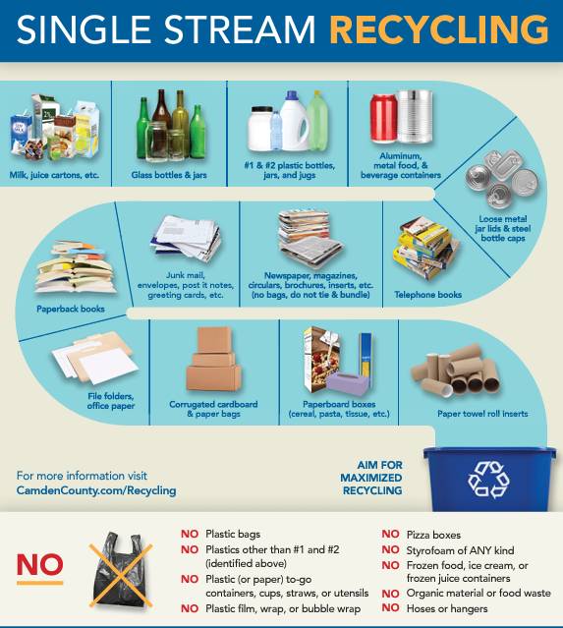
#1 - #7 plastic
NO Plastic Bags NO Pizza boxes
NO Organic material or food waste NO hoses or hangers
NO Plastic film, wrap or bubble wrap NO Styrofoam of ANY kind
NO Frozen food, juice, or ice cream containers

RECYCLING IS COLLECTED EVERY OTHER MONDAY.
PLEASE PLACE RECYCLABLES CURBSIDE ON
SUNDAY EVENING!!

